2015-16 Community Report for Michael Wallace Elementary School
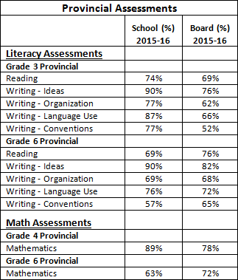

The 2015-2016 school year was the second year of implementation for our Student Success Plan at Michael Wallace Elementary. We have a writing literacy goal that focuses on generating ideas, organization, language use, and conventions. After reviewing our provincial literacy data, we are confident that our writing goal continues to be the correct area of focus for our students.

We show an overall increase in our writing scores on provincial writing assessments. Results indicate that our students are experiencing success, scoring above the Board average in all areas of writing with the exception of writing conventions in grade 6. External data results in grade three indicate that we did very well. In grade six, this year’s scores were a bit higher in writing ideas and language use, and our scores in conventions have improved by 7% from last year. This data gives us an idea of where our intervention needs to be targeted. As seen in the data table, use of proper conventions in writing (spelling, punctuation, capitalization, grammar, and paragraphing) is an area that requires further attention for students at Michael Wallace.

We feel that with continued focus, we will continue to see an upward trend. Staff continues to discuss and develop strategies and teaching methods to better support our diverse learners with their writing development. Professional development (PD), grade level professional learning communities (PLCs) and collaboration with our resource teacher and the School Planning Team ensures that there is ongoing communication at all levels.

Professional development around the area of explicit and effective feedback, writing workshop, the stages of writing development, incorporating culturally diverse materials into our lessons, developing our assessment rubrics and question practices were the main focus for PD for this year. Teachers participated in professional development on school based PD days and in PLCs, focusing on a common writing assessment rubric and explicit feedback. Our Student Success Planning (SSP) team provided PD that refined our teaching on reviewing writing workshop model and reading, and learning about how to implement strategies from an article on explicit feedback titled “Know Thy Impact” by John Hattie. PD focused on encouraging teachers to look at the writing workshop model and daily implementation, as well as the fundamental approach of teaching students in an authentic way that develops writing through rich literacy experiences. Teachers spent time reviewing best practices in their grade level PLCs.

This year’s external math scores show that we have maintained a high percentage of success in grade four, but there is room for improvement in our grade six scores. Our grade six students’ scores decreased from 85% meeting expectations to 63% meeting expectations this year. Teachers are actively working to implement a constructivist approach to math teaching in their classrooms. More time and energy has been spent on how to incorporate problem solving into daily practice. Our school based data indicates that we need to work on communication in problem solving. We determined that teachers need to communicate and have daily problem solving questions to help students improve in this area. Teachers have identified areas for improvement in their own instructional practices and this will be a focus moving forward.

