Michael Wallace
Grades 3,4,5,6 School Supply List 2023-2024
- 1 1" binder (no zippers please)
- 4 duotangs in assorted colours (preferably 1 yellow, 1 blue, 1 red, 1 orange,)
- 3 pocket folders (plastic if possible)
- 1 pkg. of 80 pg. exercise scribblers (similar to Hilroy, no coil bindings please)
- 1 ½ lined ½ blank Hilroy exercise book (green cover)
- 1 package of 1cm grid paper (grade 4 only)
- 1 hard covered writer’s composition book (available at dollar stores, see the picture as an
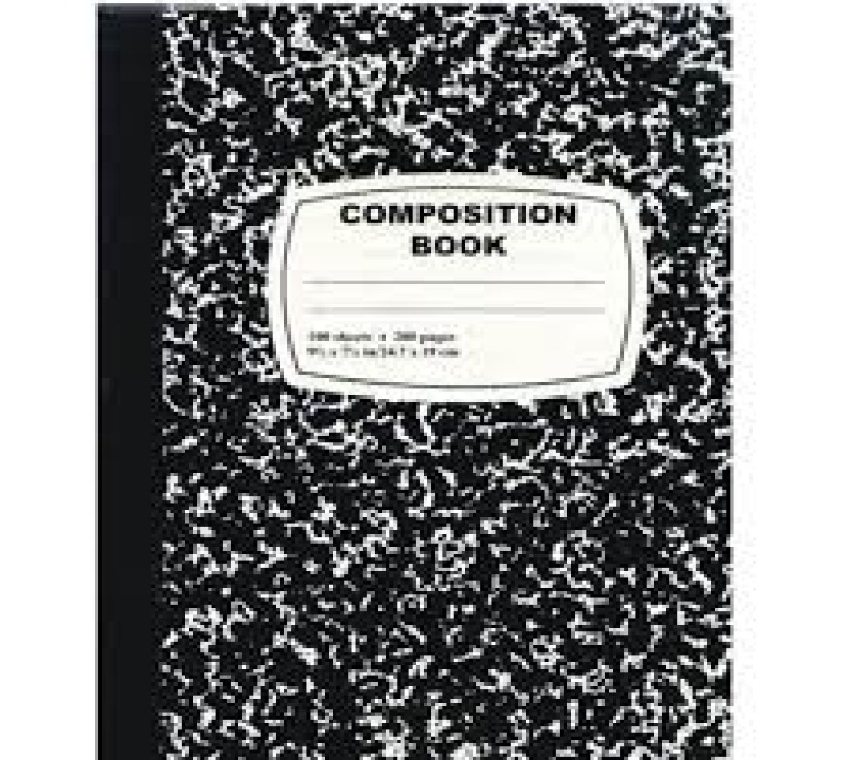
- example
- 1 box 24 coloured pencils (sharpened if possible)
- 1 package of fine line markers – not scented please
- 2 packages of regular markers – not scented please
- 1 package of crayons
- 1 sharpener (that can hold shavings)
- 1 30 cm metric ruler
- 2 ultra fine tip Sharpies (available at dollar stores)
- 1 pair scissors (good quality with slight point)
- 4 Large glue sticks (please buy good quality – it is more cost
effective in the end)
- 4 white erasers
- 5 packages of HB pencils (sharpened if possible)
- 1 pencil box/container for supplies
- 1 package of thin whiteboard markers (Expo brand if possible)
- 1 set of headphones (Dollar Store)
- For Phys. Ed. 1 Pair of sneakers with non-marking soles (for indoor use, to be left at school)
- For French: 1 duotang (grade 4 only)

Optional:
2 Boxes of tissue
1 USB mouse for use with the Chromebooks (can be found at a dollar store)
1 box of large ziploc-style bags

These school supplies are intended to last the students the majority of the year, however, you may be asked to replenish some items throughout the year such as pencils, markers, and glue. Before going shopping, please check your child’s supplies from last year, as they may not need everything on the list.

Thank you! ☺

